Yorkshire County Cricket Club
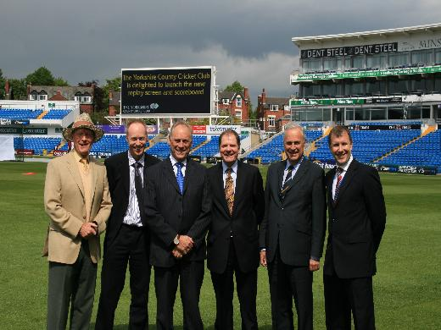
Yorkshire County Cricket Club installs digiLED screen. The displayLED team was delighted to win the contract to supply and install a new 102 square metre replay screen. The digiLED screen, which was installed in time for the first One-Day International on May 21st, will also act as a cricket scoreboard and replaces the existing scoreboard adjacent to the East Stand. This will be a significant improvement for spectators and will be the largest permanent LED display screen in professional sport in the UK.
The digiLED Ld10S screen measures 16m (wide) x 6.4m (high). With an effective pixel pitch of 10mm and a physical pixel pitch of 20mm, the digiLED screen has a total 800(w) x 320(h) physical pixels and 1,600(w) x 640(h) effective pixels. The bespoke LED modules configured to give a total display area of 102.4m2, measure 1,600mm (w) x 1,280 (h). The system comes complete with digiPRO HD video processing and the scoring system was supplied by displayLED's partner, Technographic, who have been involved in cricket scoring since 1998.

